**Strategy & Planning Session**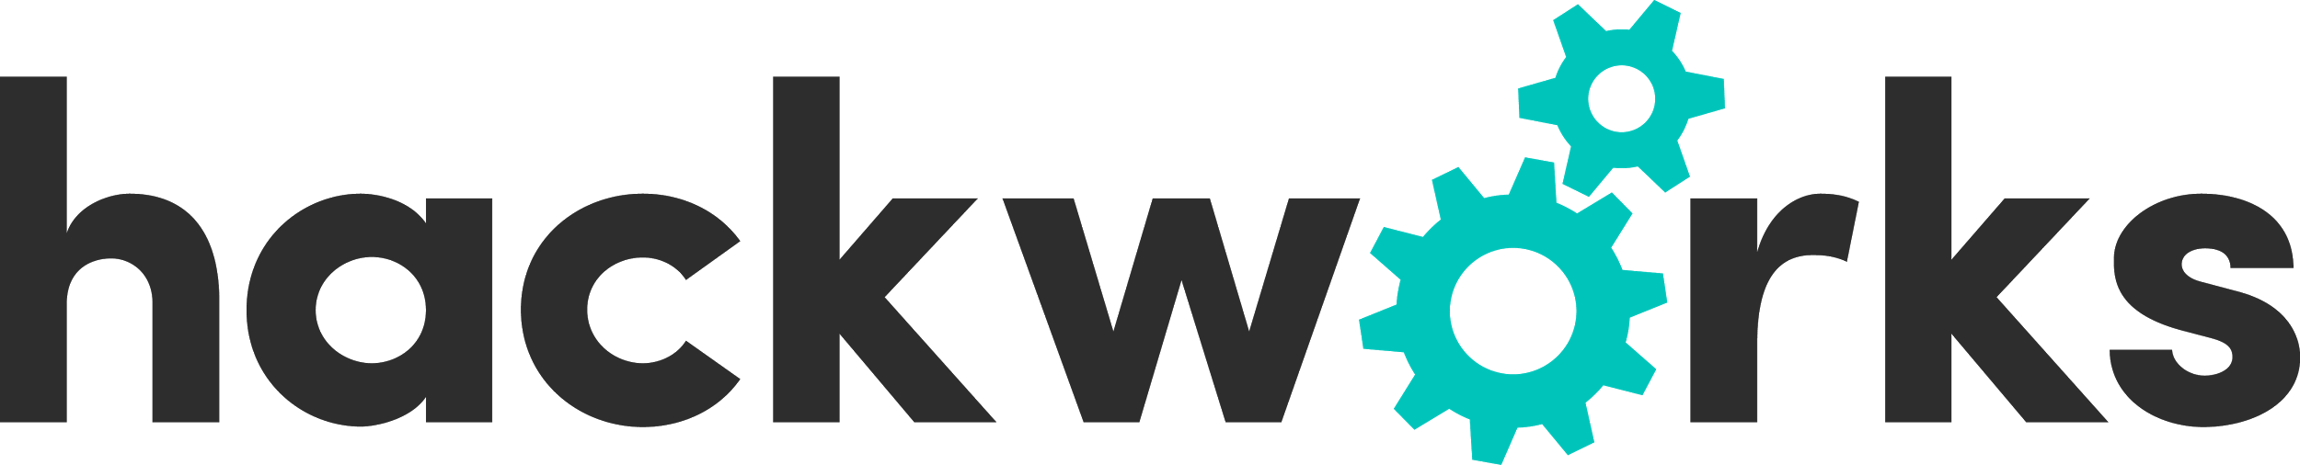

...because any plot to take over the world still needs good planning!

Everyone should start thinking about what we need to do as a company to build our brand, get new clients, make more money off the clients we have etc.

Most importantly, every discussion on this day needs to end in a list of action items. Even if it's "yeah, I'll think more about that", it's an action and someone is taking responsibility for it. And we're going to capture all of those actions all day and then we can prioritize everything and tackle it all.

**Agenda:**

9:00 - 9:30: **Hackworks Overview**

*Moderator: PM*

Patti will give an overview of what we pitched to investors and are expected to achieve in the short, mid and long term. This will include a list of tangible goals like the number of hackathons (local and national), what revenue and profit we need to make on each as well as what non-hackathon goals we have committed to, like the recruiting aspect of our events.

This meeting will set the tone and make sure all our following discussions are a means to achieve what we have promised to do as a company.

9:30 - 10:15: **Hackworks Community Building**

*Moderator: LS*

This session will be focussed on what marketing mechanism we can use to create and grow our own community of hackathon participants. Some questions to ponder:

* How do we connect, build and sustain a relationship with potential participants?
* Should we be hosting/attending/sponsoring local events? If so, which ones?
* How do we collect participant information and engage them when they’re not participating?
* What marketing tools are available and most suitable? (social, email marketing, rss blog feeds etc.)
* How do we build a strong relationship with professors at the right universities? Or are campus ambassadors sth we would like to look into? How would we incentivize campus ambassadors and account for the fact that they may be short lived because of the generally limited time students have at schools?
* How do we engage and build a rapport with other target audiences, like the investment community or incubators/accelerators/innovation hubs or even press and other influencers (for eg. the open data community reps)?

– 15 minute coffee break –

10:30 - 11:15: **HR and Recruiting**

*Moderator: PM*

Recruiting and the possible “easy money” that we could make off of placing participants is a huge potential for Hackworks to monetize. Let’s figure out a way to make this happen. Things to ponder:

* How can we evaluate the quality of participants? How do we evaluate each individual participant if it’s a team submission?
* How can we make recruitment relevant information available to clients?
* Do we have the expertise we need in-house or should we plan on getting external partners? For example a university to develop sth that will help us make better evaluations on participants’ code, or a recruiting partner that will help place participants etc.?

11:15 - 11:45: **Hackworks Website**

*Moderator: PM*

The Hackworks website will be our main HUB both for clients and – down the road – participants. Some questions to ponder:

* What will the general structure be? Will we have two separate portals one aimed at participants and one aimed at clients? What should the differentiators be for these two sites?
* Do participants need to log-in? Will they have a hackworks profile so they can easily participate in more hackathons?
* Do we want to be able to host hackathons on our site for free – similar to what Challengepost is doing? What could the pricing tiers for sth like this look like? Who would our clients be for this? Could we differentiate ourselves from Challengepost by allowing for bilingual content?

11:45 - 12:30: **New Business & Marketing**

*Moderator: PM*

New business will have high priority for the foreseeable future.Some questions to ponder:

* Can we “recycle” some of our pitches and send it to potential new clients?
* What marketing techniques can we implement now to receive more RFPs?
* What’s our “minimal viable hackathon” and what would such an event look like? (the [low-low-low-cost version](http://i.imgur.com/DWVm75L.jpg))
* What kinds of new clients would we like to target? Where do we see the most potential and highest chance of success?
* Let’s brainstorm some potential targets in the following categories:
  + Open data
  + API/Software providers
  + Gaming
  + Social good (wild card)
* Is there an industry that is in dire need of a hackathon or in which a hackathon has never taken place before? The [breastpump hackathon](http://breastpump.media.mit.edu/) for eg. is off the beaten path and did well both in terms of attendees as well as [news coverage](https://www.google.ca/search?q=breatspump+hackathon&ie=utf-8&oe=utf-8&gws_rd=cr&ei=HchtVaKOFIn6oQTk8oDYBw#q=breast+pump+hackathon&tbm=nws) (including CNN, Business Insider, The New Yorker, HoffPo, ReadWriteWeb etc.).
* Is there a hackathon that benefits society that we should be looking to score as our CSR (corporate social responsibility) event at break-even costs?

12:30 - 1:30: **Lunch & Space Hack Presentation**

*Lunch will be provided.*

Andrew will give us a quick 25-30 minute rundown of how the space hack was organized, who were the clients, the team organizing it, the sponsors, how did they manage the fact it was global, prizing structure etc. etc.

1:30 - 2:30: **CODE 2016**

*Moderator: LS*

Lets’ discuss what worked well, what didn’t and how we can improve on the event. Questions to ponder:

* How will we involve provinces/municipalities?
* Were the road show stops valuable? Should we plan on doing these again?
* What about VIP/Partner HUBs? Do we need the differentiation? How can we better help partner hubs get participants?
* How can we drive more participation?
* How should we involve the ODX?
* How do we involve local open data communities?
* Should we reconsider pitch day and grand finale events?
* How can we make CODE more attractive to sponsors?
* Who are sponsors targets for CODE 2016?

Things to keep in mind:

* Elections are in November → GoC basically shuts down for a month
* GoC seems to be very keen on doing CODE on IODD
* We need to involve municipalities/provinces
* We should plan on involving the ODX somehow

2:30 - 3:30: **GCA5**

*Moderator: LS*

The GCA was our first hackathon and is unrivaled when it comes to the passion of participants. Let’s talk about how we can improve on this even more. Questions to ponder:

* How do we build a lasting relationship with the game development/computer science/digital art course profs?
* How can we motivate profs to give out credits to students from participating?
* How can we incentivize profs to stay engaged?
* How can we further grow participant numbers?
* What are our sponsorship targets? What extra value do we have to offer them? What sponsorship tiers and numbers are realistic? How much $ do we need to get from sponsors to make this (at least) a break-even event?
* GCA submissions: how will we handle reviewing the submissions?
* Judge targets?
* Should we keep the Grand Finale?

– 15 minute coffee break –

3:45 - 4:15: **Assignments**

*Moderator: CD*

Courtney will make sure that all we’ve talked about gets assigned to a person. This person will then be responsible for taking the task to the next level and to keep moving that task forward. We will all agree on timelines and set goals. All this will then later be added in Mavenlink.